AI

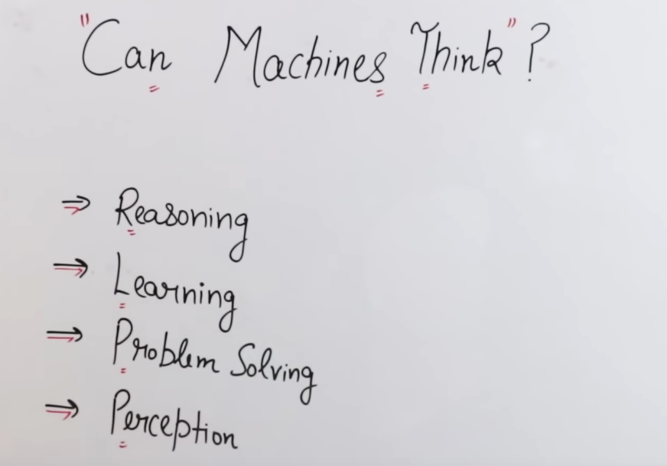

Reasoning is what actions are taken with respect to the perceived environment.

Learning means learning from past actions and history.

Problem solving is reaching from initial state to goal state.

Perception is when machine observes the environment and operates on it.

STATE SPACE SEARCH

It is another method to represent a problem. 4 components are there of state space search:

1. Set S: contains start states
2. Set G: contains goal states
3. Set of nodes: all the states are considered as nodes
4. Edges/arcs: line that link 2 nodes.

Number of states a problem can go. We have start state and goal state and all the intermediate states of the problem that are taken to reach to the goal state can be found using state space.

Firstly we have to :

1. Precisely describe the problem steps (how to operate it eg. Game rules like chess)
2. Analyse how to use the précised steps to solve the problem.(how we can play the game)

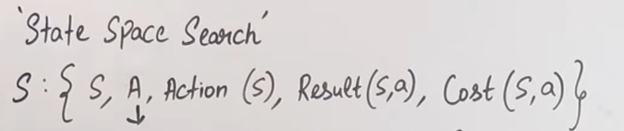

S: start state, goal state

A: set of all possible actions

Action(S): present action that is chosen

Result(S, a): the result of present action

Cost(S, a): the distance covered and we select minimum one.

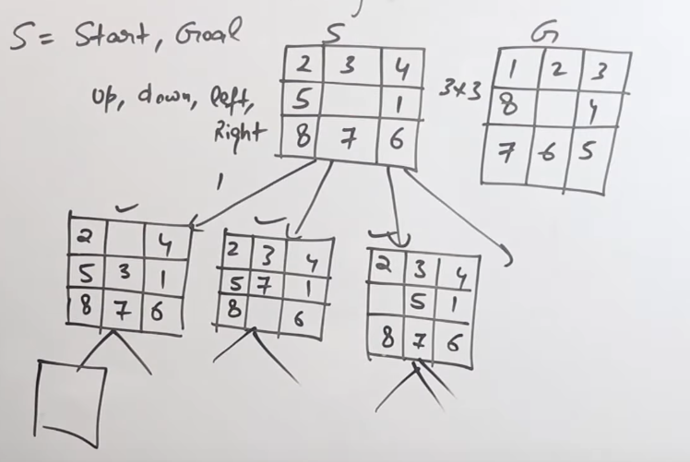

SEARCH TYPES:

1. INFORMED SEARCH
2. UN-INFORMED SEARCH (BLIND SEARCH): O(bd) (Brute force method in which all states are search to get the goal state)

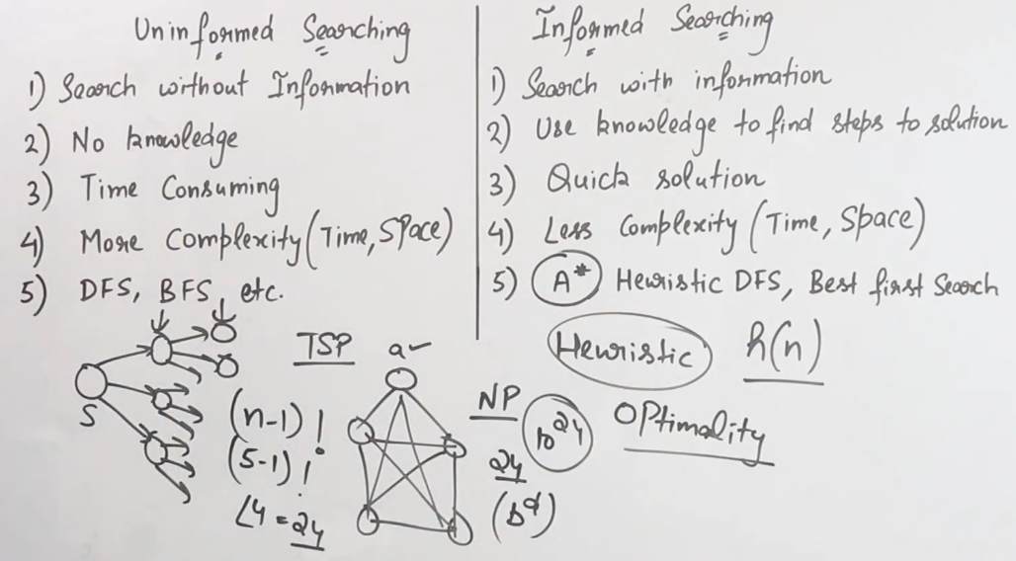

AGENTS

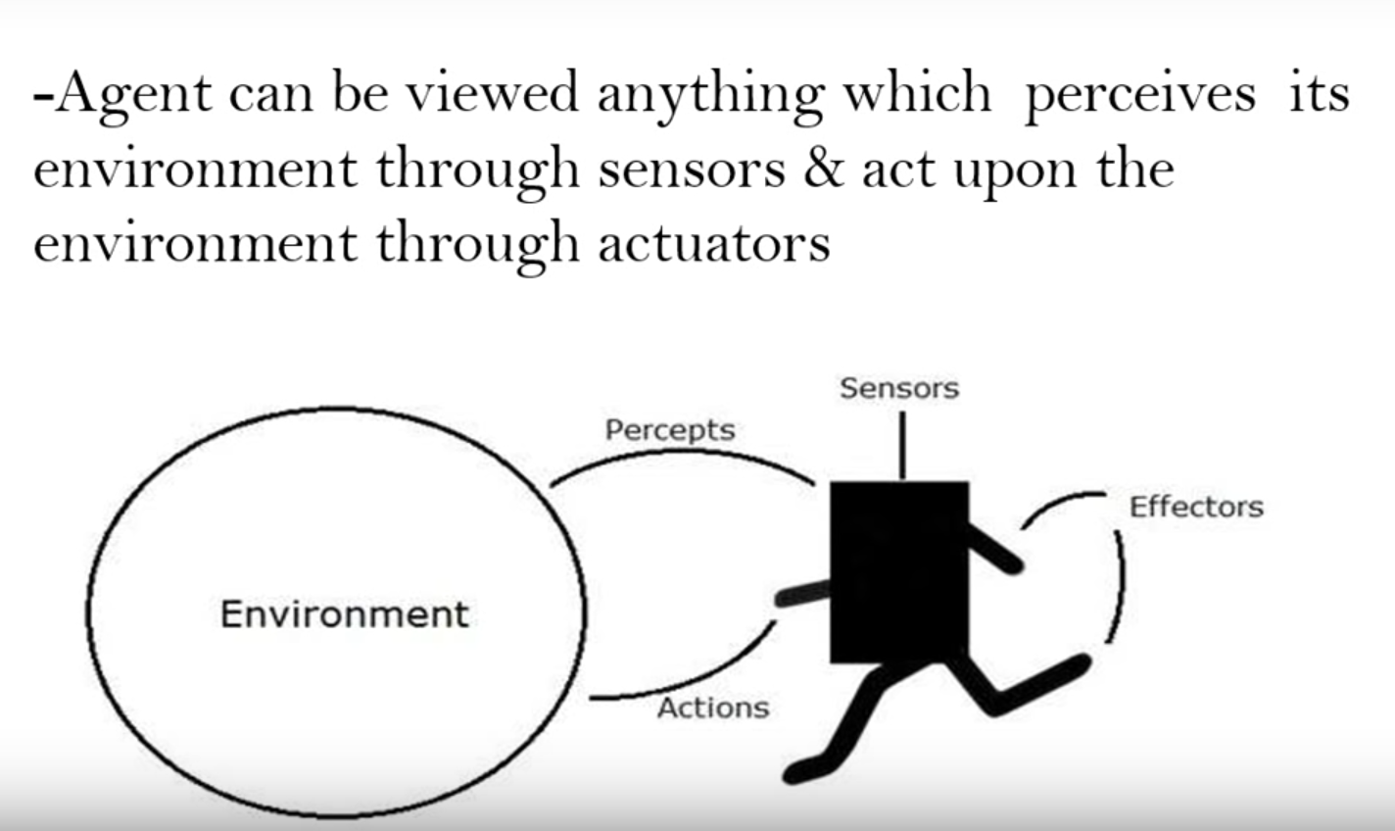

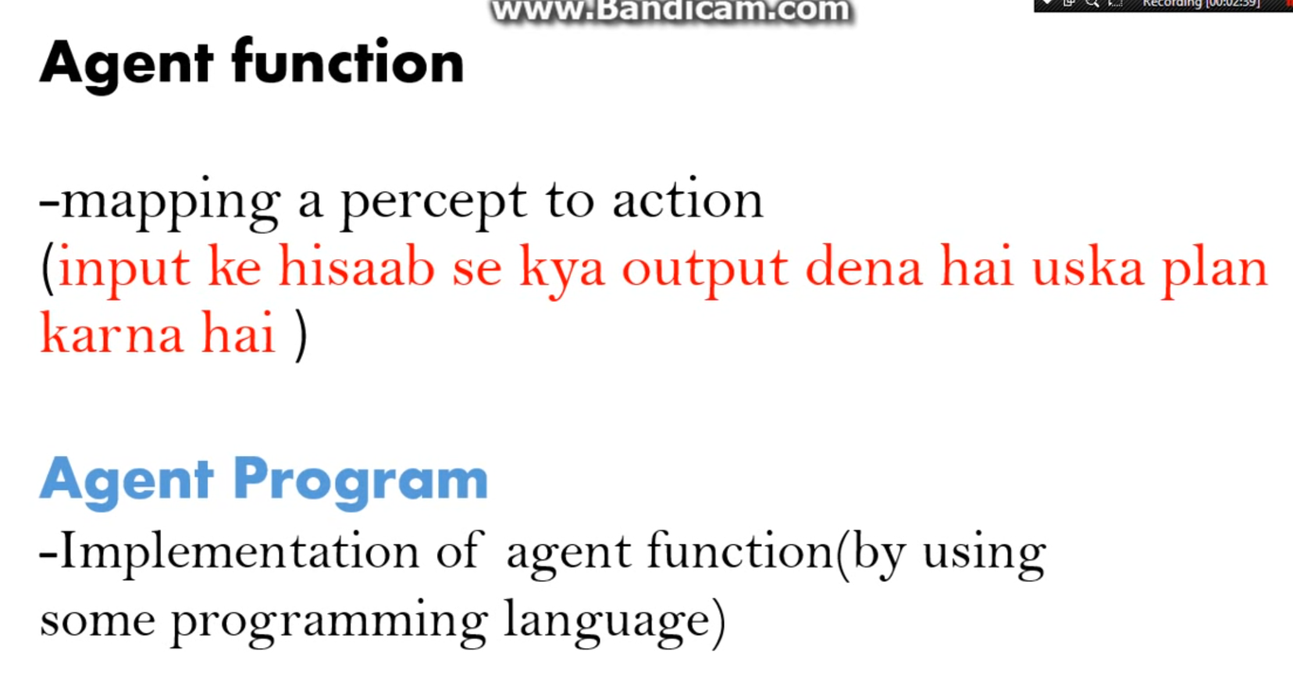

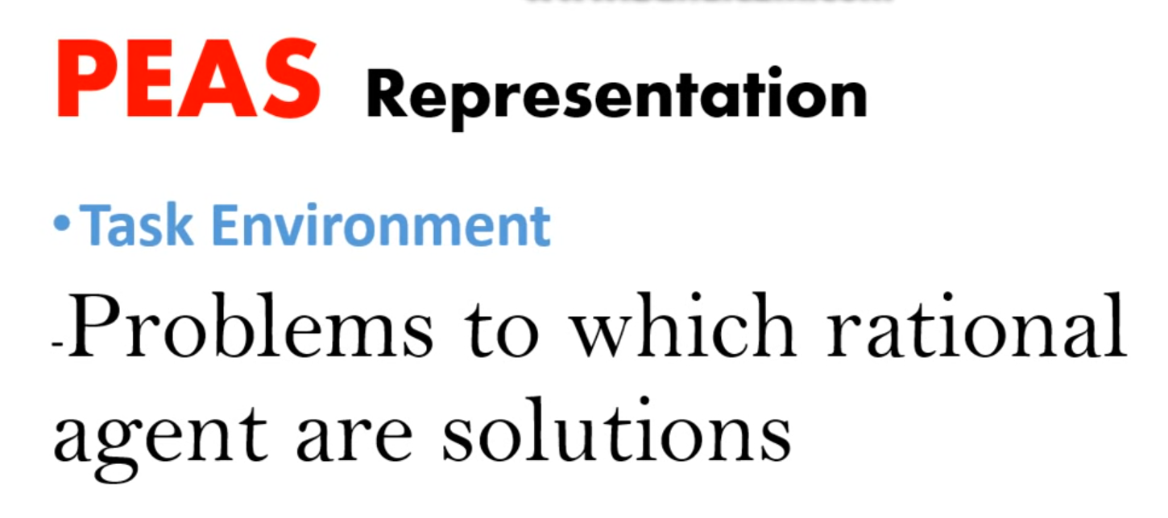

RATIONAL AGENTS ARE THOSE WHO ACTS ONLY THE ENVIRONMENT AND THEN PERFORMS THE TASKS.

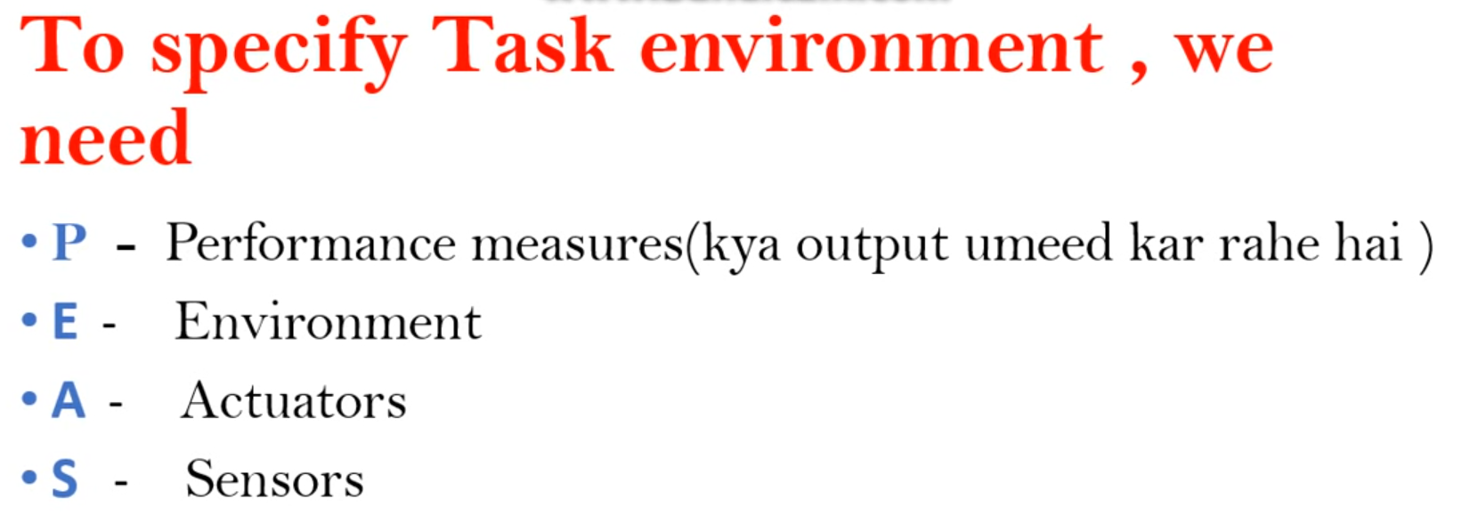

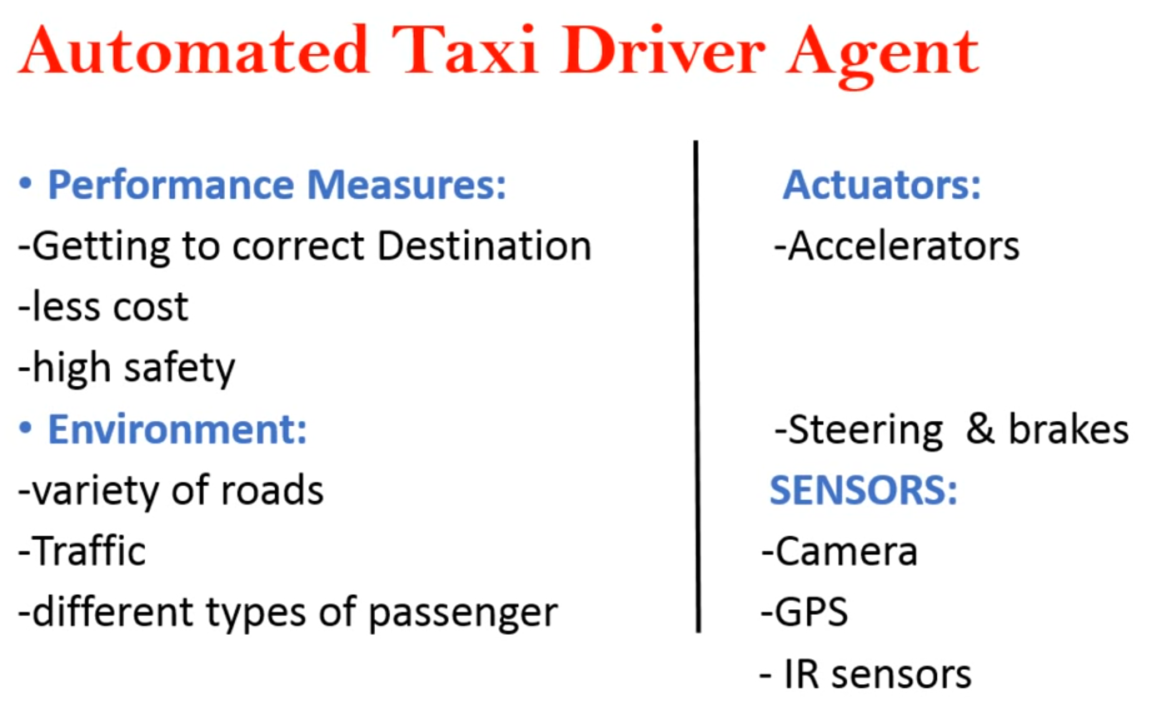

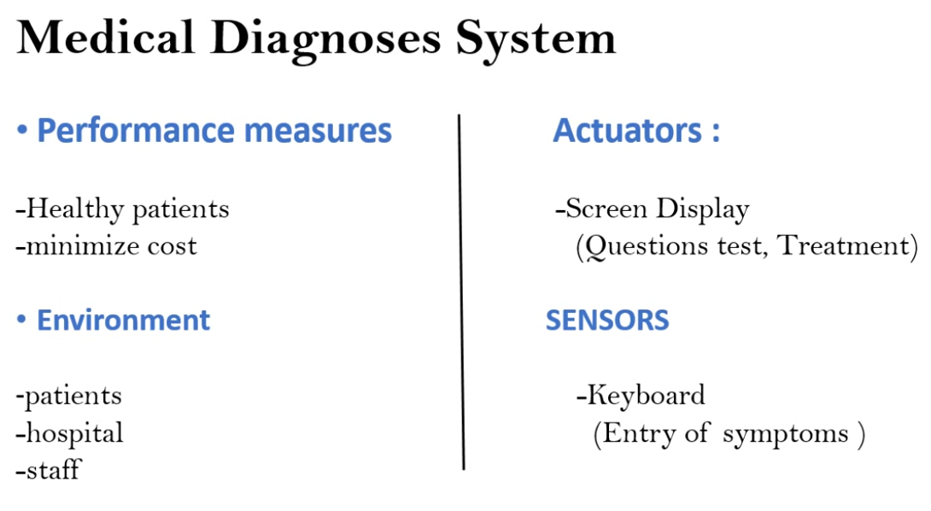

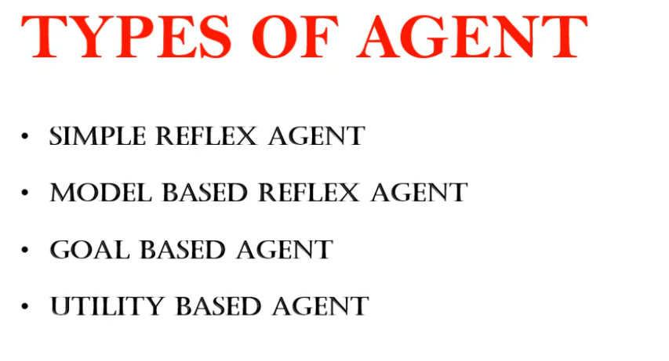

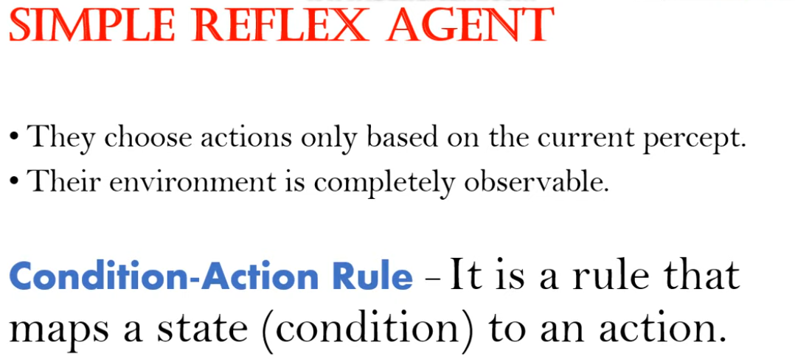

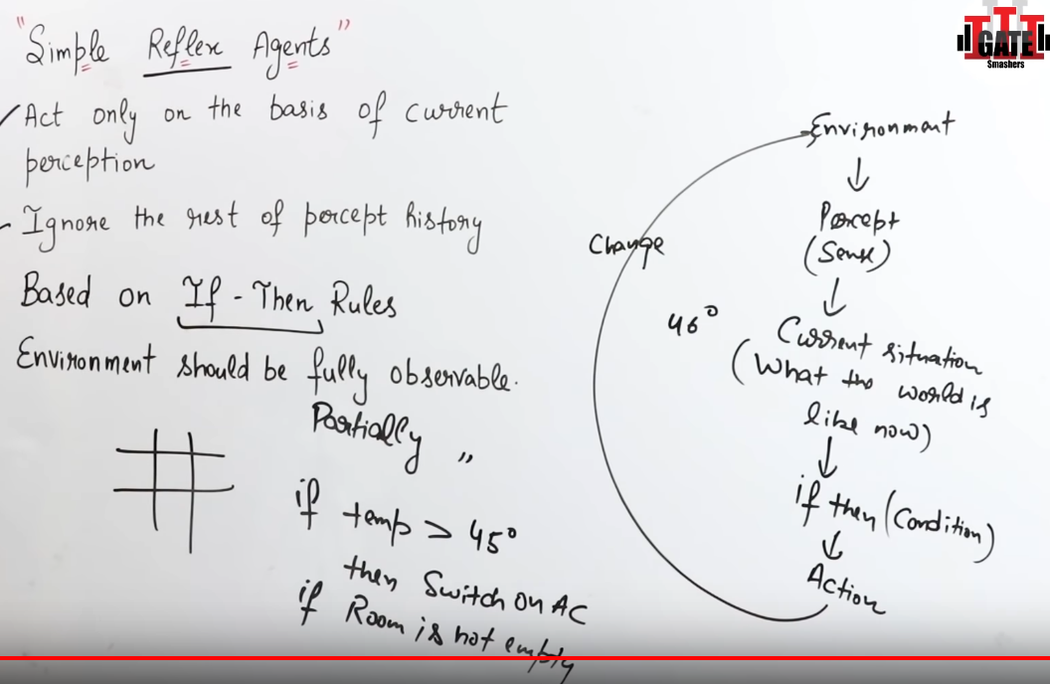

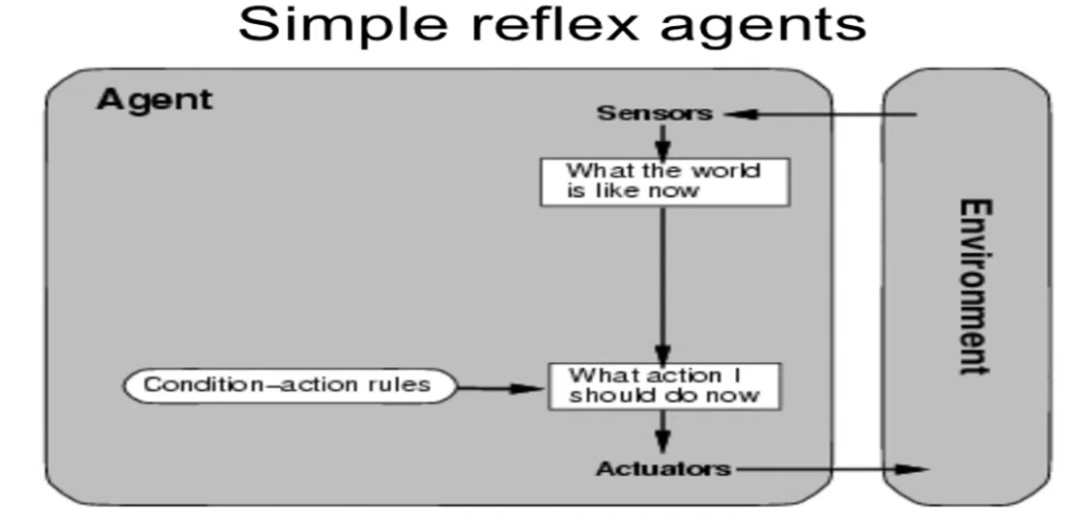

EXAMPLE: tic tac toe, chess game

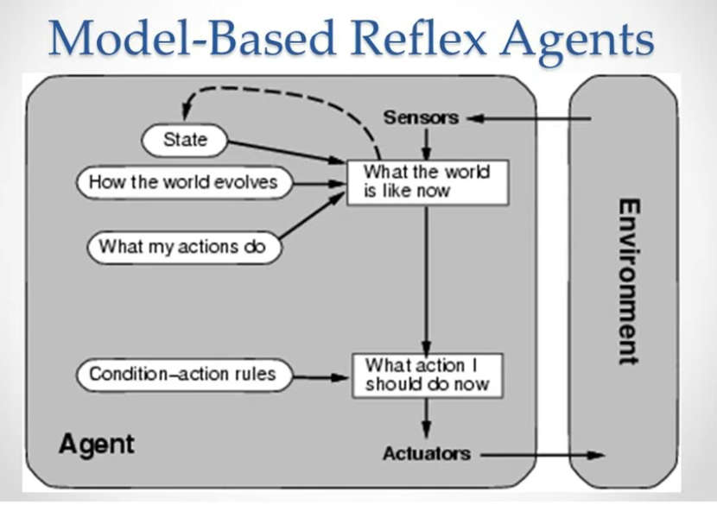

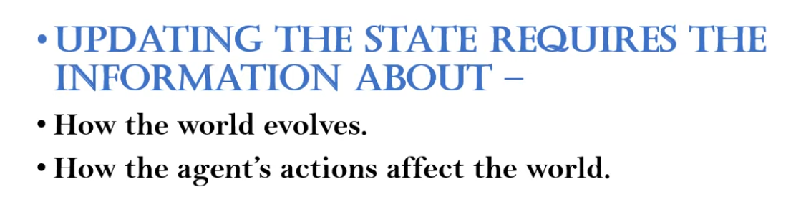

EXAMPLE: human brain

Partially observable environment

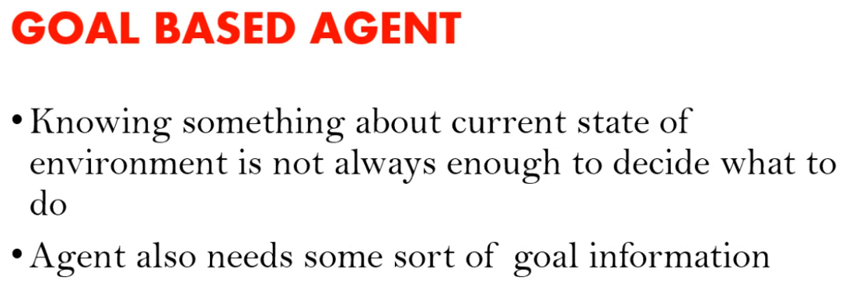

Supervised learning

Example: delivery agents by Alibaba company(china)

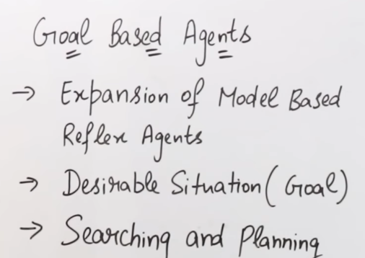

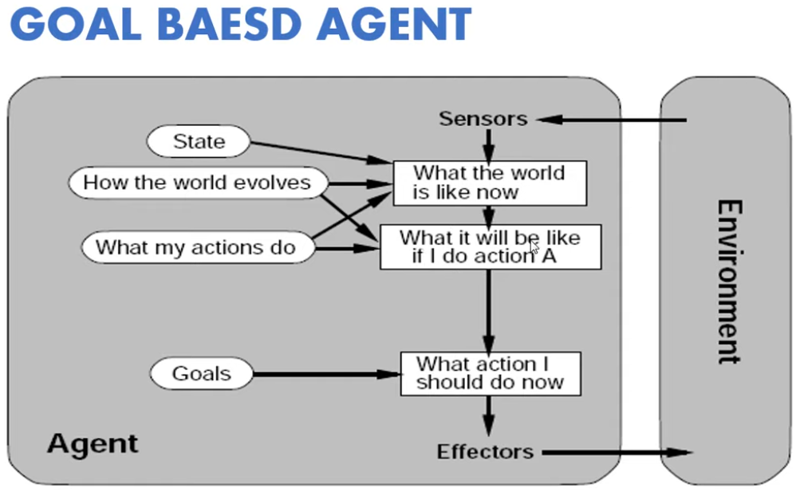

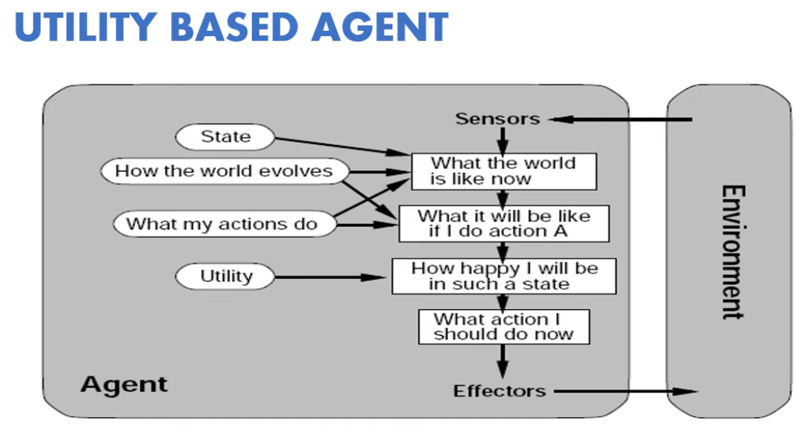

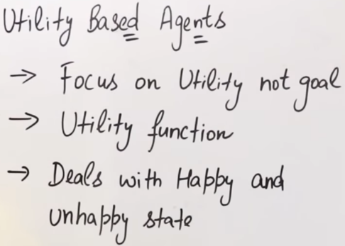

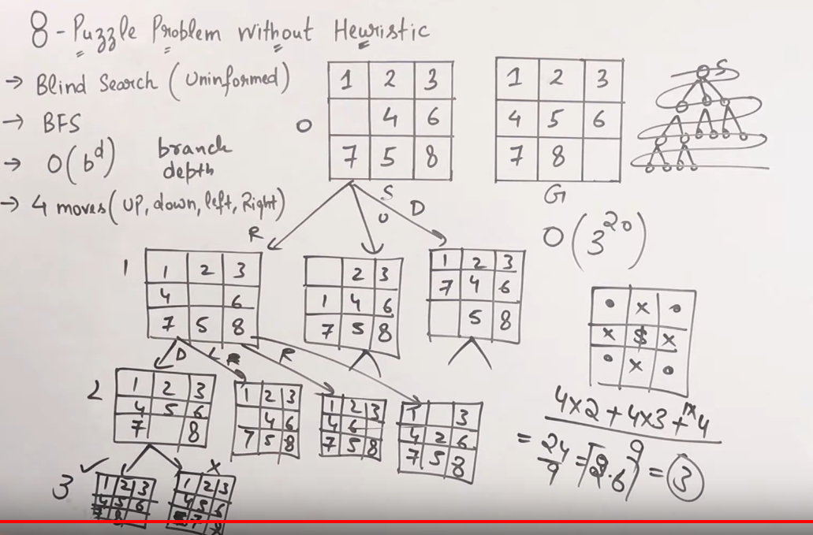

HEURISTIC : it is a value which helps to reduce the time of solving a problem. They guarantee good solution but not the optimal solution.

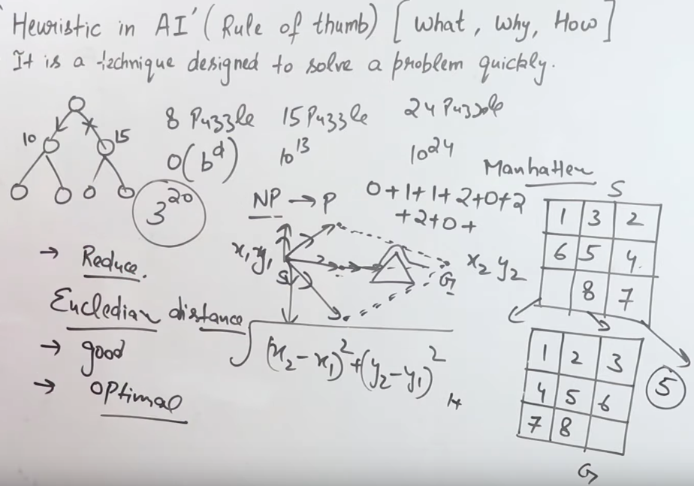

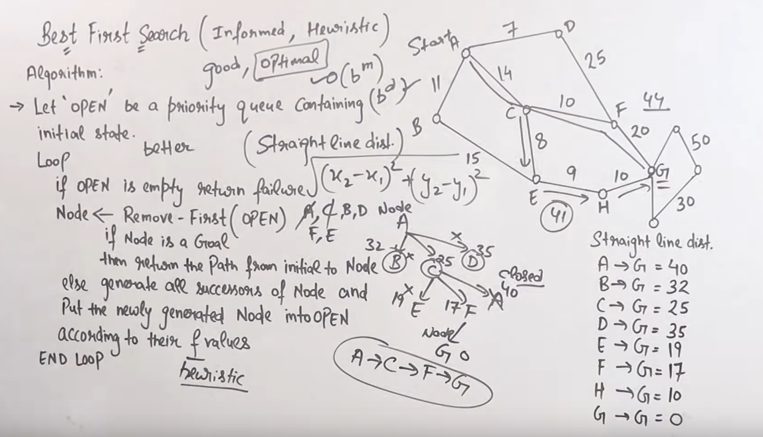

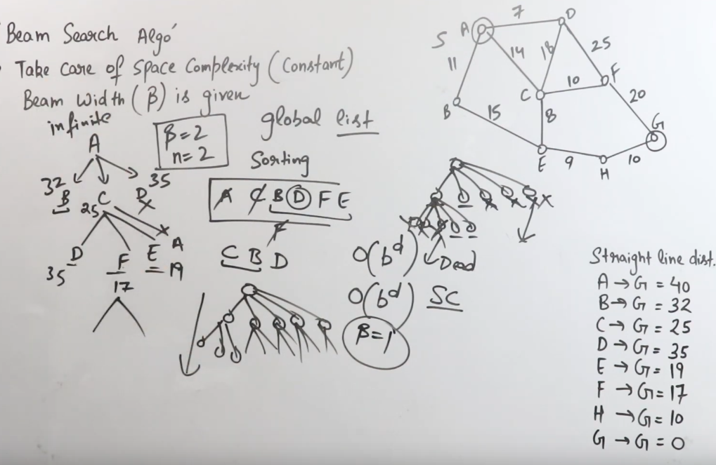

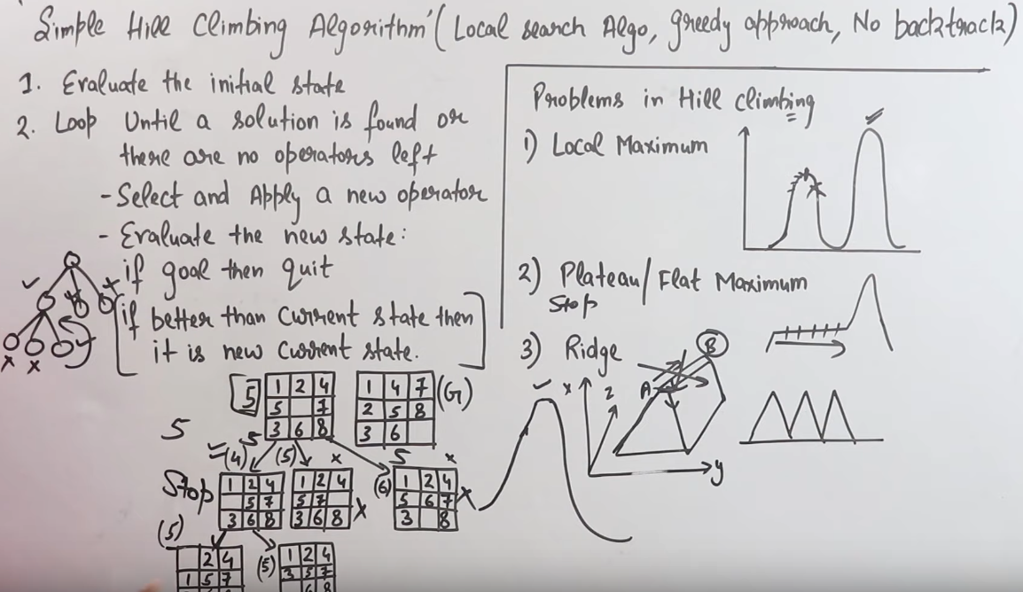

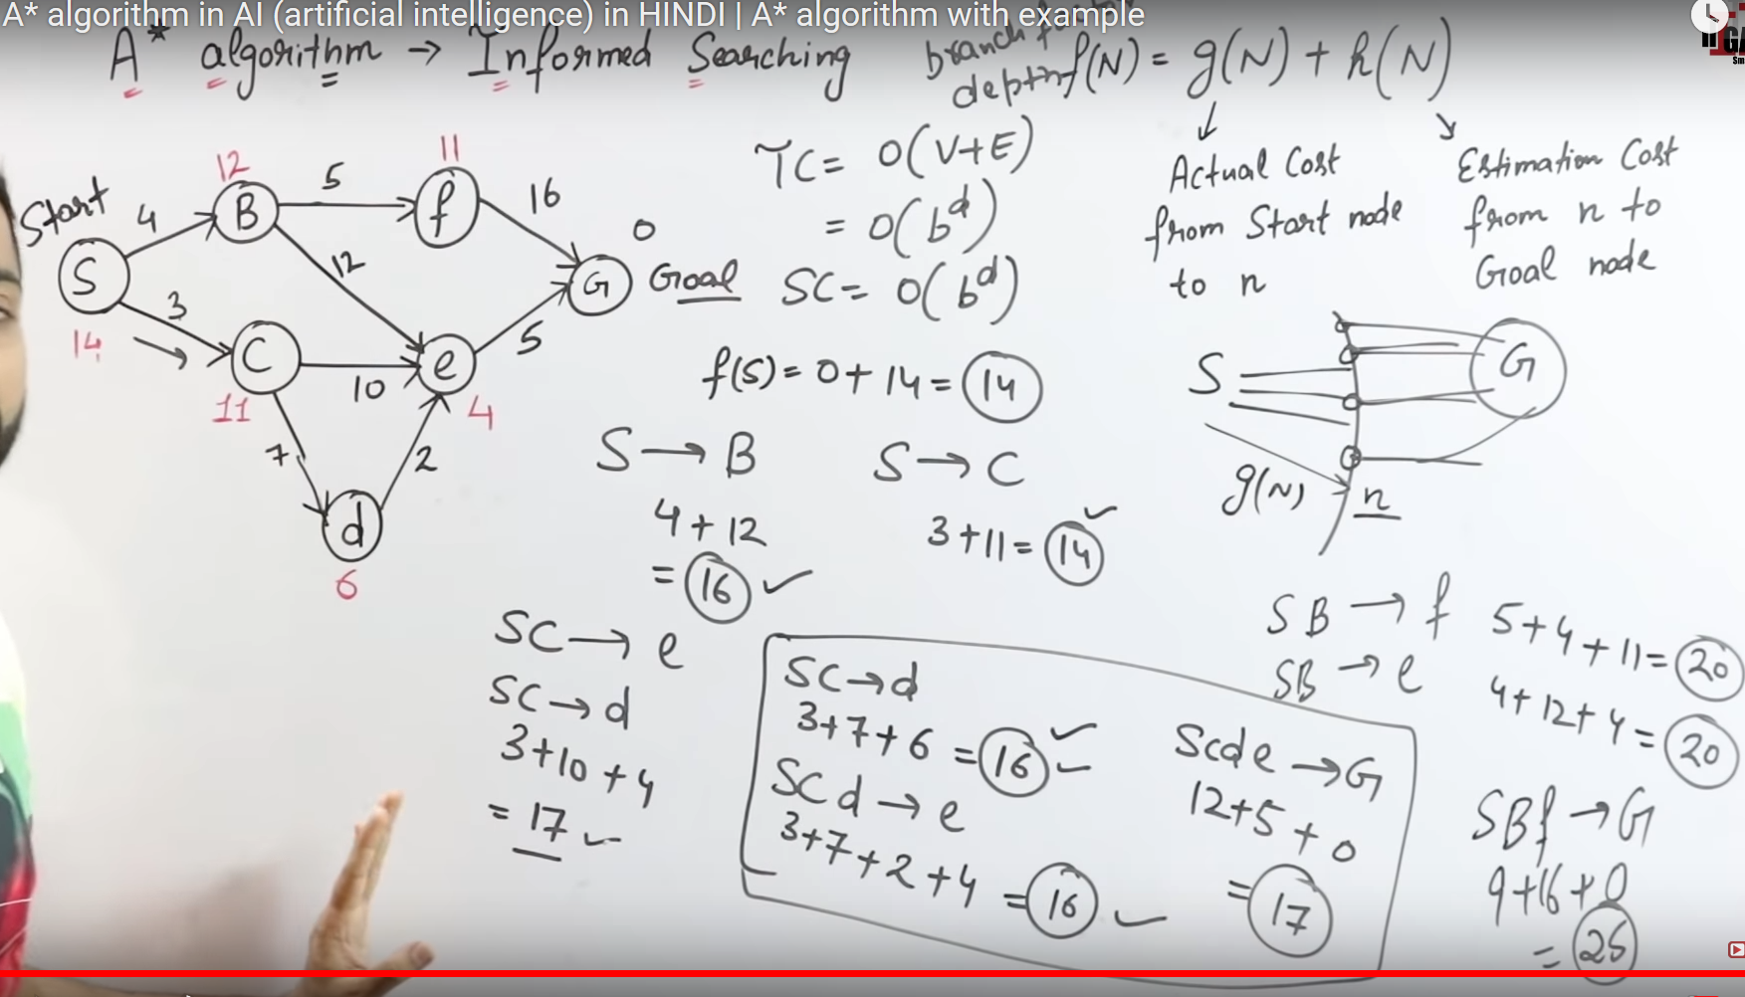

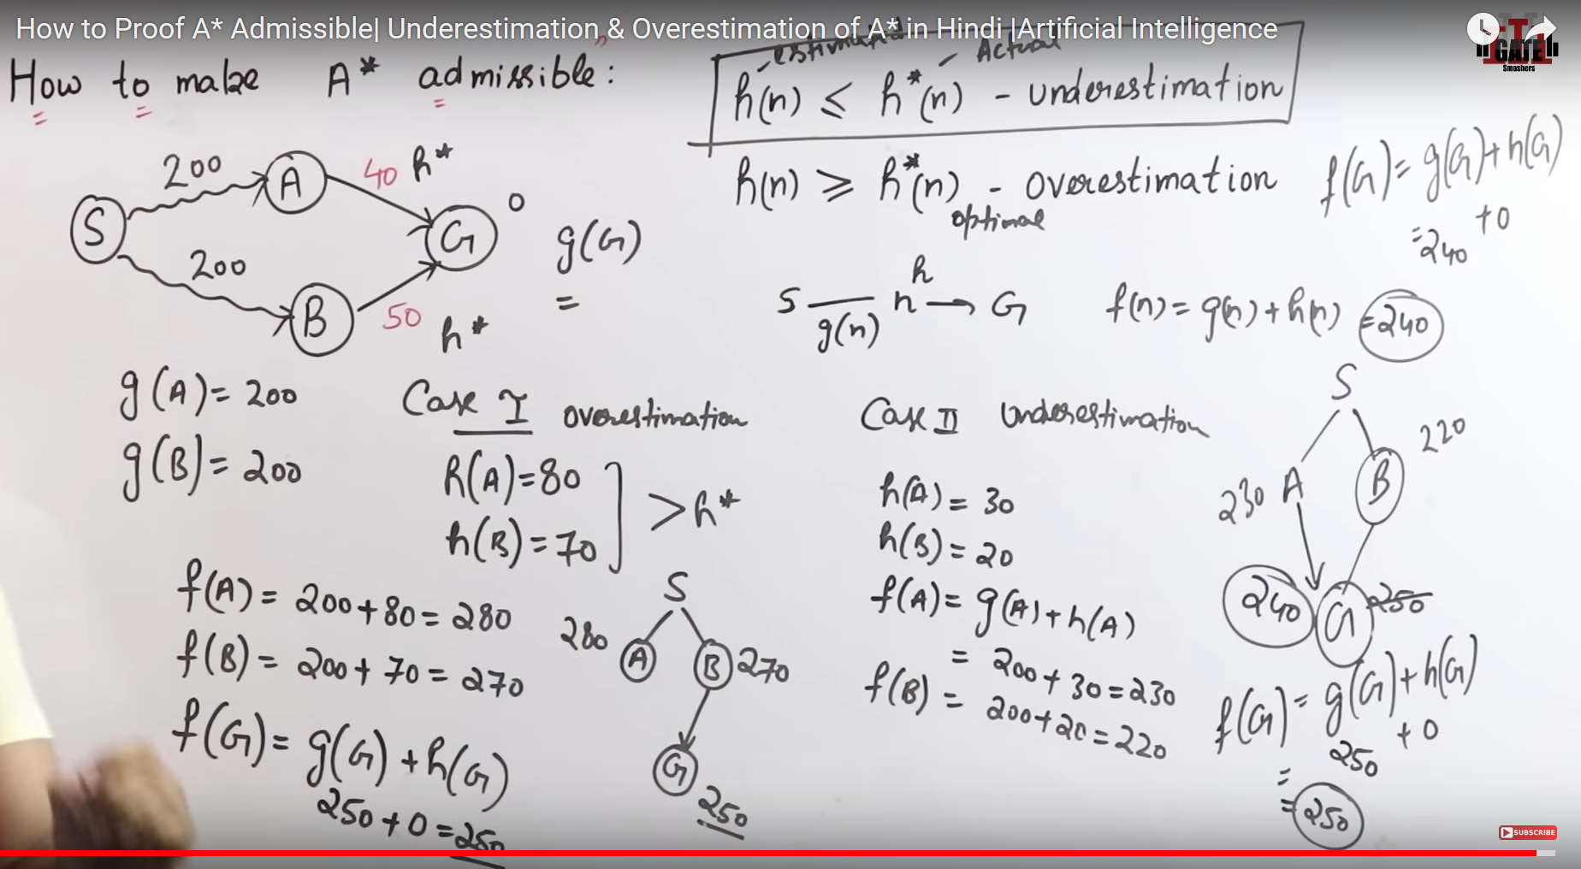

ITERATIVE DEEPING IN A\*

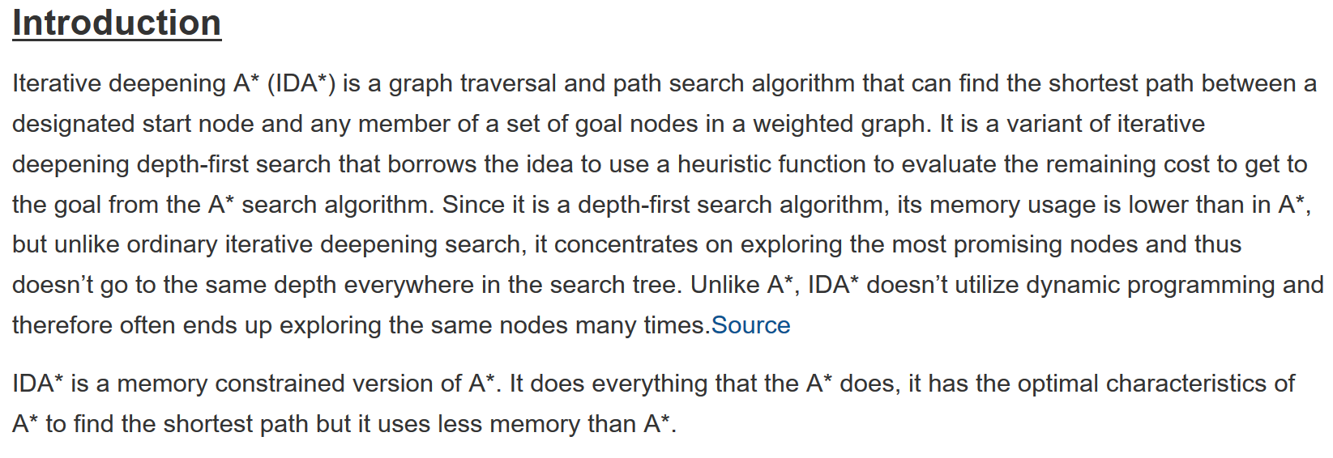

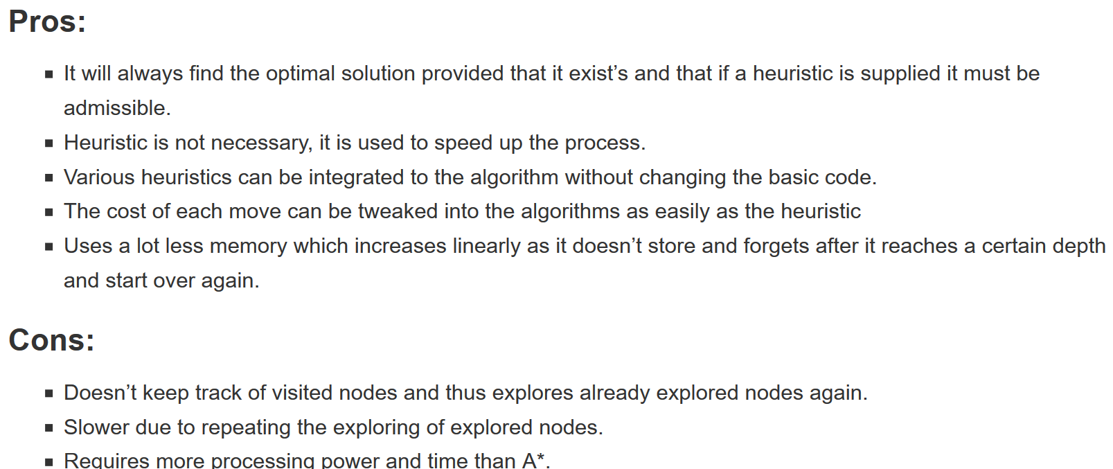

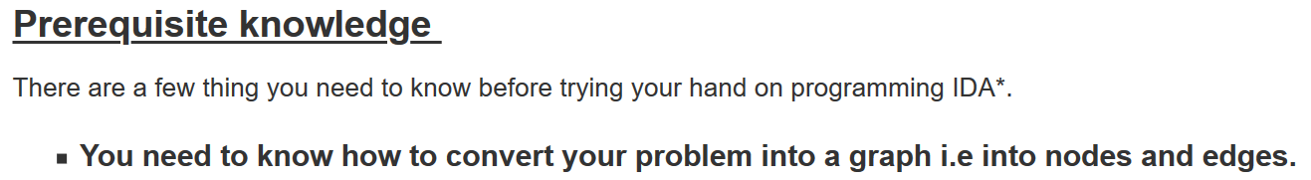

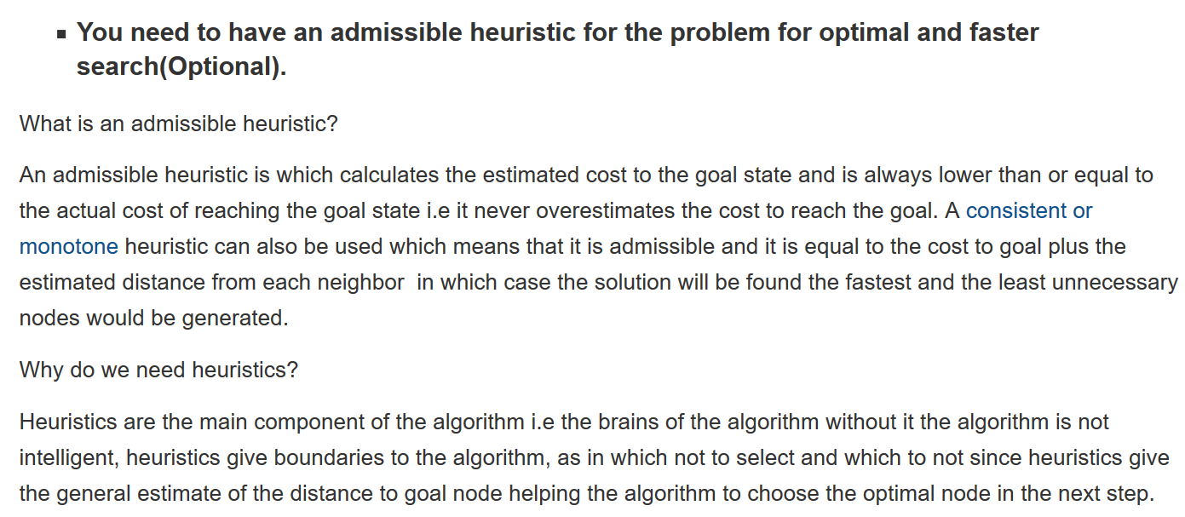

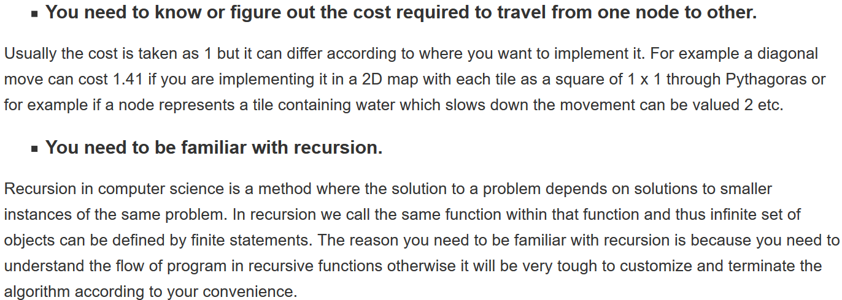

MINIMAX PROBLEM

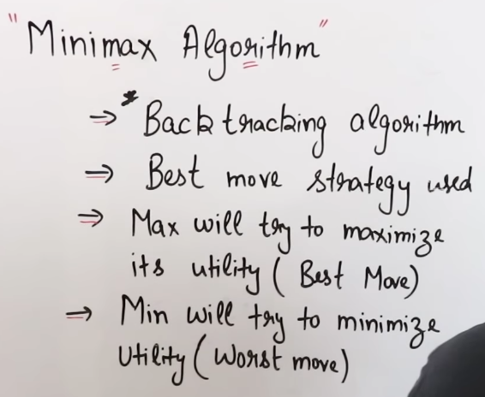

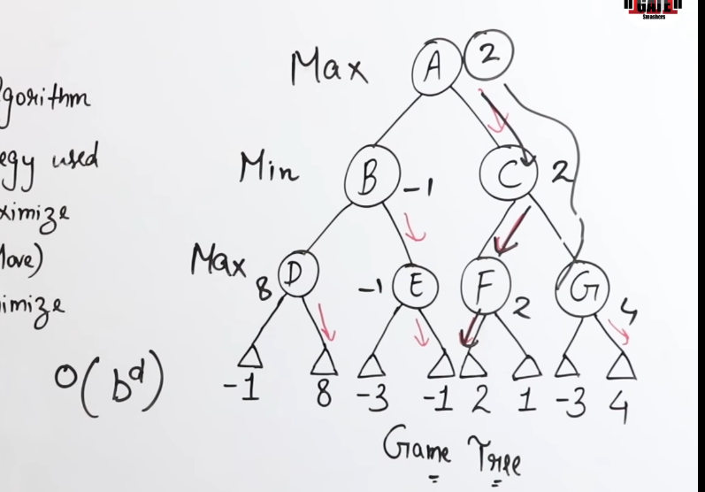

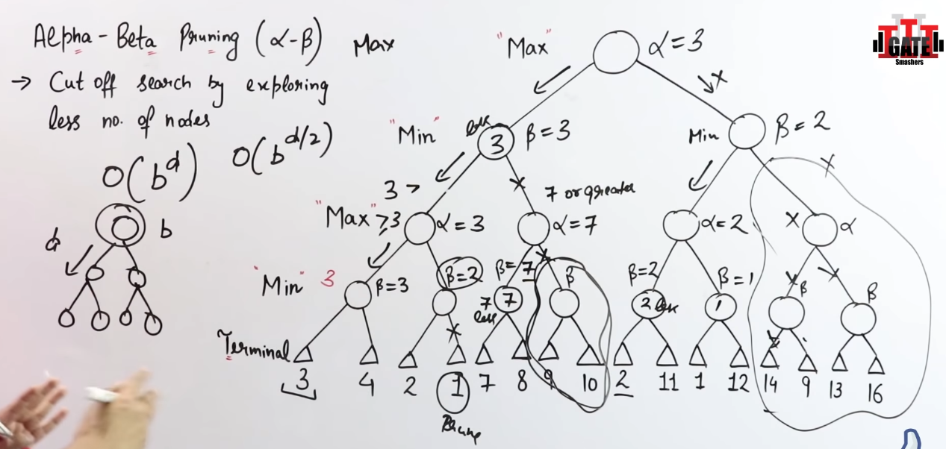

CASE STUDY

